Life Moves Pretty Fast: Beneath the Surface of Rushing Water

By Olivia Rosen
Freshwater Biology, Fall-2023, University of Maryland

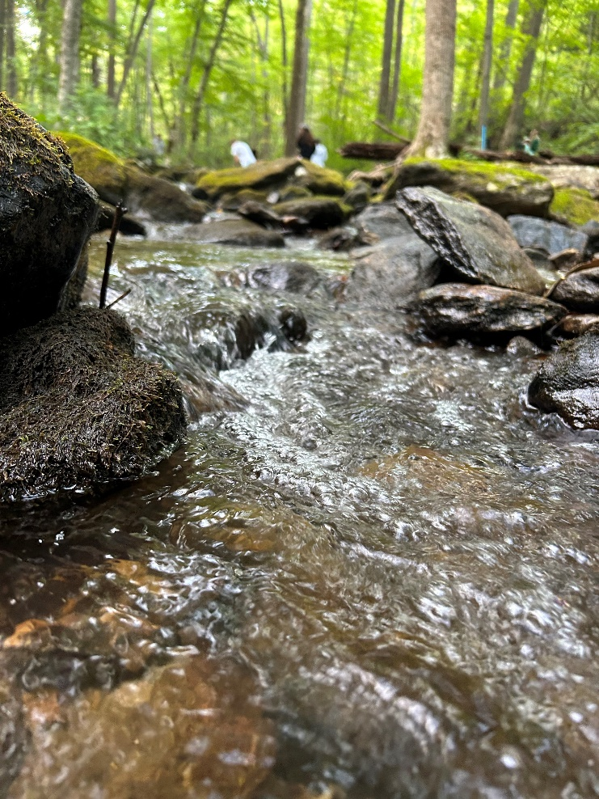
A babbling brook. The phrase evokes first sound, and then the imagery of a stream, often running through a beautiful landscape, with water rushing over rocks and stones. At Fishing Creek, the picturesque scenery of a rushing stream is framed with trees and foliage reaching to the sky, a rare stretch of uncompromised forest in the densely packed state of Maryland.
At first glance, the stream may appear to be beautiful, but seemingly empty. It is not deep enough to support large fish, and the water moves so fast that most plants struggle to grow. But within the stones and silt, there is a plethora of life. Yet with water rushing so quickly, not everything is able to brave the rapids.
In some ways, the speed of the water benefits organisms- running water is often a better source of oxygen for those that dwell in it, with the rapids and rocks churning the water much like one would picture a mixer whirling ingredients into dough. On the other hand, the rush of water means that anything not firmly anchored in place is at high risk of being washed downstream. Plants and animals must be specifically adapted for resisting the constant pull of the water.
Fishing Creek, MD; photo by O. Rosen
Some of these organisms have quite unique adaptations that help them in this fight against gravity. Certain species of mayflies have flattened heads and bodies, allowing them to cling closely to rocks and live relatively unaffected by the water rushing past. Plants like moss create rhizoids, tiny hair-like structures that allow them to grip the rocks they live on without the need for fully developed root systems.
With tools like these, life abounds in the stream, even with the difficulties creatures may face. The rush of water not just a source of pleasant ambient sound, but also a factor to consider what life could be below. The babbling brook may seem like a simple phrase for a simple place, but within it there are many lives and hardships to go with them.

